PARISH NEWS
The Deverills & Crockerton

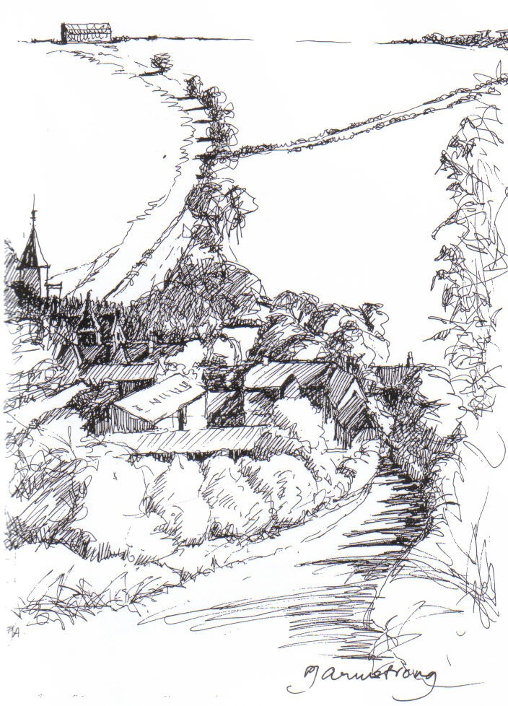

King’s Hill, Kingston Deverill
by Pat Armstrong

July 2009

Look inside for local information

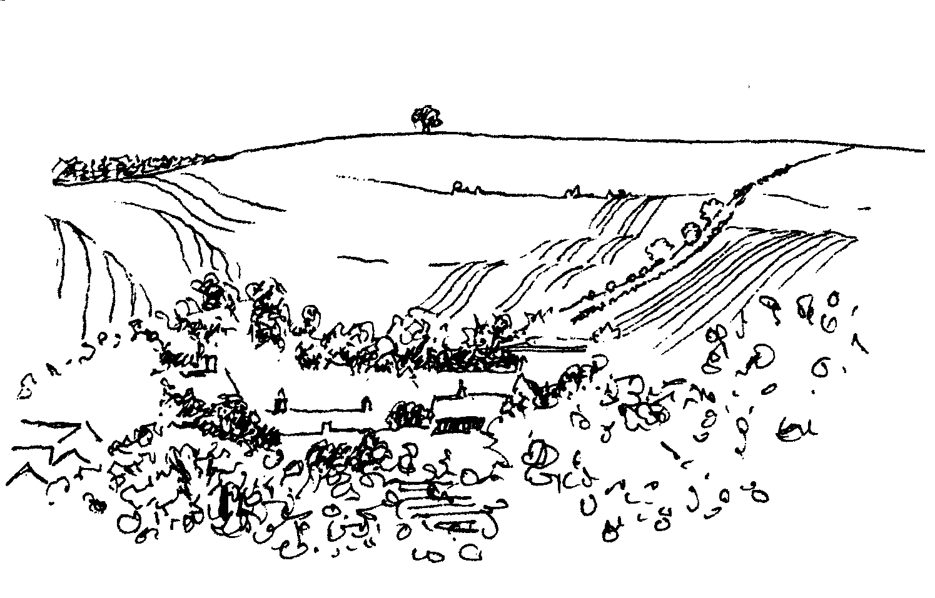
-2-

Longbridge Deverill House - Care Home for the Elderly
SUMMER FETE
Saturday 11th July 2.00 pm
Cake, Handicraft and Plant Stalls, Pets Corner
Cream teas, Raffle, Tombola,
Music & entertainment for all, please come and join us

CROCKERTON VILLAGE COMMITTEE
Mid Summer Party at Bath Arms Crockerton Saturday 18th July from 6.00 pm
Come to a great summer event for Crockerton & local area
Music, Food, Fun, limited space so please book early
£7 adults £3 children (5-10 yrs) Under 5’s free
Ring: Marion – 213739, Tracey – 216939, Bernie – 218401
Longbridge Deverill Village Hall
Quiz Night - Saturday 25th July
Commencing at 7.00 pm for 7.15 pm
Entry £6.00 per person - including a fish and chip supper
Tickets available from Sylvia Titt 214825
Bring your own drinks - glasses provided
Other Forthcoming Events: September - Harvest Supper
October - John’s Local Talent Music Night, December - Carol singing
Music In the Deverills Saturday 1st August 8.00 pm
4-4 Jazz band
St Michael’s Church, Brixton Deverill Tickets £10 (inc. glass of wine)

Pre - concert supper 6.30 pm
Manor House Brixton by kind permission of Johnny & Pony Burridge
Tickets £10 (inc. glass of wine) Call 01985 840877
Cheques payable: PCC Deverills & Horningsham - profits Deverill Churches Fabric Fund

Coffee, Cards and Chat
Come and enjoy looking at the new range of cards,
ribbons, wrapping paper, and other exciting items
displayed by John and Maddie Goodden
in the Upper Deverills Village Hall on Thursday 19th February
between 10.30 and 12.00 noon - everyone is welcome
Donations will be made to the hall and the church

-3-

The Rector writes:
In a book by Michael Mayne, written shortly after he retired as Dean of Westminster, there appears this quotation from Virginia Woolf’s book ‘To the Lighthouse’.
“What is the meaning of life? That was all – a simple question; one that tended to close in on one with the years. The great revelation had never come. The great revelation perhaps never did come. Instead there were little daily miracles, illuminations, matches struck unexpectedly in the dark.”
Given the present situation in the financial world and in the world of politics, together with the challenges with which many are faced from day to day, finding those ‘daily miracles’ becomes life saving. Acts of kindness or an encouraging word, the sight of something special can be the match struck in the dark. The things which really touch us are responsible for keeping hope alive when situations seem black.
The older we are, the more poignant that knowledge may seem. Expectations change. If we are lucky, tolerance and understanding increase, and we become increasingly aware of the need to live well each day. By that I mean living in a way which puts the needs of others before our own, living knowing that what we do matters, leaving a lasting legacy for good or ill. The little miracles, the illuminations, the matches struck unexpectedly in the dark are there to see if we keep our eyes open. Without realising it, we may be the means of bringing those special things to others.
The words of this Sanskrit proverb summarise well the importance of making each day count, so that what we do becomes ‘life giving’ and not ‘energy sapping’.
Look to this day! For it is life, the very life of life. For yesterday is but a dream. And tomorrow is only a vision. But today well lived makes yesterday a dream of happiness. And tomorrow a vision of hope. Look well, therefore, to this day!
We may not be nearer to defining the meaning of life, but life will definitely have more meaning.
Norma Payne
Christian Aid
Thank you to everyone who gave so generously making the total for this year of £621.78. Many of you completed the gift aid form which will mean an extra 28%.
News from Dr Francesca Elloway - Democratic Republic Congo
Francesca’s life since Christmas has been dominated by administration and account activities rather than her medical work, she is very grateful for help received from a friend at home to prepare the accounts for audit. Baba is officially in charge but he still needs another year’s training, which started in May in Uganda. The building work on the Medical Health Centre in Mahaqi continues. In February Francesca attended a dental seminar, which she found very interesting, but has not been able to put into practice as yet. Also in February she visited Tapale where one of her helpers in Aru is now a pastor, this is outside her catchment area so she cannot practice there, she asks for our prayers for them. At present Francesca is back in Bristol for a two month break, however her time in the UK last year was dominated by work with little rest. Please pray for Ezati who is now in charge while she is away and for the people in the Congo still suffering from recent wars. (A copy of her letter is in each church.)
Elisabeth Atkinson

-4-

Daphne Woodcock
The Deverills and Crockerton have suffered a sad loss with the untimely death in May of Daphne Woodcock. She leaves behind her husband, Ian, three daughters and seven grand-children, all of whom were devoted to her, and of whom, in turn, she was immensely proud. For more years than most can remember, she was involved in many aspects of village life, giving great support to the Church, the Almshouse Trustees, the Women’s Institute, the Flower Club and the local school. At the same time, she helped in the running of a farm, whilst raising a family and supported village occasions with samples of her excellent cooking. She was a very gentle lady, good-natured and friendly, quietly getting on with life while holding high principles, but forgiving of those whose standards were not as high as hers. She will be greatly missed by her many friends, particularly by those with whom she regularly played Bridge, as a companionable opponent. It is a privilege to have counted oneself amongst those friends.
Richard & Elizabeth Diacon
Mental Notes
Those of you who regularly read my wife Jane’s Nature Notes in the Parish News will probably have noticed there was no contribution from her last month. This was because she has been quite ill and in hospital. On April 20th, she went down with an influenza virus and I got it two days later. This turned out to be a particularly virulent bug, unlike anything we had ever experienced before. After 2 weeks, I was starting to recover but Jane just got worse. She lost about 4.5 kilos.
When we awoke on May 7th, our lives were really turned upside down. It was obvious that Jane was experiencing a significant mental event. She was admitted as a voluntary patient to the Beechlydene mental health unit in Wilton Road, Salisbury. She was diagnosed as suffering from bi-polar disorder. People with this condition can swing from deep depression to extreme highs. The actor Stephen Fry suffers from it. Jane has had odd bouts of, relatively mild, depression in the past, but in this instance she had an extreme high. Her brain was running so fast that she could not distinguish between what was real and what was imagined. She was extremely upset and confused. For me to leave her there, that first night, when she was begging me not to go, was the most distressing experience that I have ever had. She was given the appropriate drug treatment, and within 48 hours she was quite rational, although physically weak. She gradually progressed taking short walks out into Salisbury with me, to odd nights at home, and was home fully after 16 days.
Beechlydene is a light and airy modern unit, built 7 years ago, providing patients with their own en-suite room and numerous activities to aid recovery. Members of staff were incredibly kind, the food superb. One drug which Jane is taking increases appetite, and she replaced all her lost weight, whilst there. Following her discharge she has been monitored by home visits to check on her progress and adjust the drug doses etc. Nothing is too much trouble. We are so grateful for the treatment she has received from the good old NHS. Jane will not be allowed to drive for a while; in the meantime, she is catching up with her gardening and getting back to normal.
Clive Trollope

-5-

Thank you to Dilys Noorlander- Longbridge Post Office
The post office closed its current services on 18th June and Dilys retired having served Longbridge Post Office for the last 22 years, 12 years in her own village shop and 10 years at the Service Station. We, as a community, are extremely grateful to her for the devoted service she has given us and for all her hard work. We wish her well in her retirement from the Post Office and in her future.
New services at Longbridge Post Office:
Mondays, Wednesdays and Fridays 9.00 am – 2.00 pm
Thank you
I would like to express my very grateful thanks for the kindness shown to me by so many people in the parish and beyond before, during and after my operation and stay in hospital. It was lovely to have all your cards, phone calls and messages, to say nothing of the practical help in taking me about when I was not allowed to drive my car, and doing shopping for me etc. I also want to pay tribute to my dear friend Sylvia Titt, who looks after me like a mother hen and without whom I would not have been able to manage at home on my own. I am happy to say that the operation was completely successful, I am now free of all pain, and as mobile as I am likely to be at my age (I doubt I can run!). It is so nice to go to church again.
Sue Hunt
Brixton Wedding
Thank you to everyone in Brixton Deverill who helped to make our wedding day at the end of May so special. Some of our neighbours very kindly took time to arrange tidying of the church and churchyard at Brixton Deverill. It was all done as a surprise for us and we were delighted and very touched by such kindness, the church looked wonderful. Our thanks also to Nigel and Sue at Langleys who invited us to walk through their beautiful grounds to and from the church, our photographer taking advantage of their stunning gardens to take some wedding photos. The Burridges very generously let us use their driveway for parking which was greatly appreciated. We would like to thank Norma for a beautiful service; we had a lot of fun preparing for the wedding and were delighted that Norma married us. The guests talked about the wedding ceremony long into the night and will for years to come. Thanks also to Mary Stewart Cox for all her help with the church and John Budgen for playing the organ so beautifully. Last, but not least, our thanks to Pat Armstrong for letting us use her wonderful drawing of Brixton Deverill church for our Order of Service. If we have forgotten to name anyone, please accept our apologies; our sincere thanks to everyone for all their friendship and support in making our day perfect.
Chris and Chrissie Rose
RNLI ‘Lifeboats’
Very many thanks to all our villagers who so generously contributed to our recent House to House collection. The total was £457.14. A special thanks to the nine people who so kindly walked our spread out villages to make it possible - especially Edith Dyer, Monkton Deverill, for carrying the heaviest box with the highest collected sum.
Colin Singer 213696

-6-

Wylye Valley Art Trail
This was greatly enjoyed by many. Congratulations to Nick Andrews and his organisers and all those who set up the displays so well. The guide map was a great help with excellent directions and descriptions. Alas, we only seemed to see a small amount but the standard of work in the Deverills and Crockerton was very high. The new lay out and variety of work at Bull Mill needed a whole morning and it was good to see the work of talented children. Lovely pictures at the two new venues and Val Dale’s teas were popular there; as was Janet Budgen and friends’ teas at the Vineyard, which raised £100 for the Church Fabric Fund. We all look forward hopefully to another Art Trail in 2011. Thank you all so much for your hard work and giving us all such a wonderful time.
Elisabeth Atkinson
Wylye Tennis Club
Our league results are now available up to 9th June. The mixed A team are playing well and are mid table in Div. 2. Our mixed B team continue to enjoy playing but as yet to actually win a match, propping up division 5 (the bottom div.). The newly formed Ladies are doing well in their Div 4, at present being mid table. Over half the programme remains to be played so we are hopeful of more enjoyable tennis - and better results, especially from our mixed B team. Please contact me if you are interested in purchasing ex match tennis balls at £2.00 per can of four.
Colin Singer 213696
Save the Children Fund
Cream teas and open garden in aid of Save the Children will be held at Mill Farm House, Hill Deverill on Sunday 26th July between 3.00 – 6.00 pm and on the last Sunday of the following months 30th August, 27th September. Do come and join us for an enjoyable and relaxing afternoon.
Anne Hurd
Deverill Valley & Crockerton Women's Institute
Our June meeting proved to be a very jolly evening in spite of hearing about the sad end of the Russian royal family in a well researched talk by Mollie Bond. Several visitors came and joined in a lively round up of books read and enjoyed. Coffee and home made cookies rounded off the meeting. Tess, who is the delegate representing 4 local WIs, reported on the National meeting at the Albert Hall. The speakers there included Eve Pollard, Maureen Lipman and Richard Stilgoe with some young disabled and talented musicians. Surprisingly about 5% of the 5,000 there voted against the 'SOS for Honeybees'. If you are interested in how some exquisite hand made greetings cards are produced, come to see a demonstration at our next meeting on Monday 6th July at 7.30 pm in Longbridge Hall. Also there is a Gospel Choir Workshop at Longbridge hall on Tuesday 28th July - a WI event open to non members - male voices very welcome! For tickets or a free chance to come and listen, please ring Joan, 01380 831022.
Jill Russell 840209

-7-
Crockerton Forum
The eighth meeting of the Crockerton Forum was held on 29th April. Minutes of the meeting are available on the parish website at: www.deverills.org.uk/Crockerton Forum. It was agreed that over the past year some progress has been made, and the solutions which remain available to us are not currently viable. It has been an interesting year on the Forum, and I think we are in a position where we now all understand each other a lot better. It was generally recognised that whilst the problem itself hasn’t changed, a better understanding all round of the issues helps. We ended the session by agreeing some further activities to take place in terms of ‘keeping the lines of communication open’. As Chair of Governors I would also re-iterate that as a school we don’t consider the issue to be ‘closed’ because the Forum hasn’t been able to find a resolution and we will continue to explore possible solutions to the problem, one of which started in late May with the Warminster Neighbourhood Task Force meeting. It became clear there that parking is not just an issue at Crockerton, it is prevalent at all the rural schools in the area. I suggested that whilst each school’s issues are individual we should be sharing good practice and ideas on what we have tried. This was welcomed and I will be the initial contact point for the start of ‘sharing of good practice’. Hopefully we will pick up some ideas which will help further to alleviate the situation within Crockerton. If there are specific issues you wish to discuss please don’t hesitate to contact the school or if you would like to find out more about what is happening at the school please look at the school website: www.crockerton.wilts.sch.uk.
Crockerton School – New Mobile Project
The work is progressing well, we are expecting the new mobile to arrive shortly. Regular progress updates are appearing on the school website at: www.crockerton.wilts.sch.uk/new-projects/mobile/progress-updates. We recognise that there is significant disruption around the school, the traffic and parking situation is quite intrusive but we are doing our best to keep the disturbance to a minimum, and appreciate your understanding and goodwill – thank you. I look forward to telling you when the work is completed, in the meantime if you have any concerns, please don’t hesitate to contact myself or Mrs Clough via the school.
Graham Dopheide - Chair of Governors
River Update
In April I said it was the intention of both local Parish Councils to ask Wiltshire Council to consider having the river adopted by the Environment Agency (EA). With that plan in mind, the Upper Deverill Parish Council has arranged, in conjunction with the Upper Deverill Village Hall Committee, to have the EA caravan at the Fete on Saturday 18th July. This will enable people to speak to the representatives of the EA and discuss their concerns with them and will also be an opportunity for us all to become better informed. Subsequently we plan to hold a public meeting, hopefully with members of the EA and our local Land Drainage engineer, to all explore the pros and cons of having the river adopted by the EA before we take the matter any further.
Trish Shuler - Upper Deverills Parish Councillor

-8-

SERVICES PARISH OF DEVERILLS & HORNINGSHAM
The Deverills & Horningsham Register
Wedding at Horningsham Rachael Hocken & Michael Dardis - Saturday 6th June
Funeral at West Wilts Crematorium Daphne Woodcock Tuesday 2nd June
Thanksgiving Service at Longbridge Daphne Woodcock - Friday 26th June
Funeral at Bath Crematorium Mary Katherine (Mollie) Cane Tuesday 23rd June
Contact the Clergy
Please contact Norma Payne (841321) or Di Britten (01373 832515) if anyone is housebound and would like communion or a visit at home; or if someone is ill and needs our prayers; or to discuss any church matter.
Office administrator phone 210149 or email: office@cleyhill-team.org.uk

Sunday Trinity 4
5th July Brixton 8.00 am Holy Communion 1662
Longbridge 10.30 am Morning Worship*
Horningsham 6.30 pm Evensong
Sunday Trinity 5
12th July Kingston 10.30 am Holy Communion
Horningsham 11.15 am Reunion Service
Sunday Trinity 6
19th July Longbridge 8.00 am Holy Communion 1662
Brixton 10.30 am Holy Communion
Sunday Trinity 7
26th July Longbridge 10.30 am Holy Communion
Horningsham 11.15 am Morning Prayer
Kingston 6.00 pm Evening Prayer
Sunday Trinity 8
2nd August Kingston 8.00 am Holy Communion 1662
Longbridge 10.30 am Morning Worship
Horningsham 6.30 pm Evensong

*Commissioning Service for Carol Clough, Head Teacher of Crockerton School

Tuesday Wednesday Thursday Friday Longbridge 8.30 am Prayers
Wednesday Longbridge 10.15 am Holy Communion
Parish Prayer groups - These monthly groups will be starting in July
In the Deverills and Horningsham on Tuesday 7th July from 7.00 pm to 8.00 pm at the Rectory, 6 Homefields, to pray for our communities.
In Corsley and Chapmanslade, on Sunday 19th July at 6.00 pm in St. Margaret's Church, Corsley, Prayer and Praise.

-9-

SERVICES PARISH OF CORSLEY & CHAPMANSLADE
Sunday Trinity 4
5th July Corsley 9.00 am Holy Communion
Sunday Trinity 5
12th July Chapmanslade 9.00 am Holy Communion
Temple 11.00 am Sea Sunday Service
Sunday Trinity 6
19th July Chapmanslade 9.00 am Holy Communion
Corsley 6.00 pm Evening Worship
Sunday Trinity 7
26th July Temple 9.00 am Holy Communion 1662
Corsley 10.30 am Parish Service
Sunday Trinity 8
2nd August Corsley 9.00 am Holy Communion
Thank you
In the past month, Margaret and Richard Askew have moved to be nearer to members of their family. On behalf of the church we would like to thank them for their contribution to the life of our Benefice and especially the parish of the Deverills. We will miss them, but will continue to see them from time to time when Richard comes back to take a service or two.

Concert Details
Saturday 11th July A Sea Symphony in Wells Cathedral - In aid of RNLI
For tickets phone Wells Cathedral Shop 01749 672773, John Budgen 218203
Warminster Information Centre 218548 or Bath Festivals Box Office 01225 463362
Saturday 1st August - Jazz and supper at Brixton Deverill
For tickets phone Mary Stewart Cox 840877, more details see page 2
Saturday 17th October - Deverill Valley Clarinet Quintet & supper Longbridge
For tickets phone Julian Wiltshire 844152

Church Cleaners for July
Kingston - Mrs Shuler & Mrs Martyn
Brixton - Mrs Blue & Mrs Edwards
Longbridge - Monday 6 July 9.30 - 10.30 am - all helpers
Church Flower Arrangers for February
 | Kingston | Brixton | Longbridge
5th July | Mrs Dyer | Mrs Greenwood | Mrs Titt/Downer
12 July | Mrs Dyer | Mrs Greenwood | Mrs Titt/Downer
19 July | Mrs Stratton | Mrs Sutton | Mrs Robins
26 July | Mrs Stratton | Mrs Sutton | Mrs Robins

-10-
St John’s Parish Church Hall Warminster
Thursday 2nd July at 7.00 pm
An illustrated talk Pre-Raphaelite, Church Mosaic Decoration, 1870-1935
Refreshments Tickets: £3 to at the door
Saturday 11th July 10.00 am - 12.00 noon
Sale - needlework and crafts, fabrics, cottons, threads, trimmings
Bargain prices

SATURDAY 12TH SEPTEMBER
SUPPORT
THE WILTSHIRE
HISTORIC CHURCHES TRUST
TO TAKE PART
PLEASE CONTACT
JUDY MUNRO 844385



Maiden Bradley Community Shop (844206)
Friends in the Deverill Valley, the refurbishment of the shop will happen between 6th July and 12th July. The shop will reopen at 8.00 am on Monday 13th July, the official opening will be on Friday 24th July at 9.30 am by Dr Andrew Murrison MP. Meanwhile, we will endeavour to give a complete service from the portacabin in our car park. The Post Office will be closed for one week. There are freezers going free, if interested please contact the shop, thank you for your support.
Recipe from Rosie Brown - Courgette and mint soup

Ingredients - this serves 4 (hot or cold)

50 gms | (2 oz) butter | 1 large onion
675 gms | (1½ lbs courgettes | Salt and pepper
850 mls | (2 pints) chicken stock | 2 tsp fresh mint leaves (or rosemary leaves)
150 mls | (5 fl oz) natural yoghurt (cold soup) | 55 mls (2 fl oz) single cream (hot soup)
2 tablespoons of chopped chives to garnish

Method
1. Wash, top and tail courgettes, roughly slice.
2. Peel and roughly chop onion.
3. Melt butter in large saucepan, add onion, cook for 5 minutes.
4. Add sliced courgettes, cook for further 5 minutes, stirring to prevent burning.
5. Roughly chop mint leaves and add to courgettes.
6. Add stock, salt and pepper.
7. Simmer for 25 minutes until courgettes soft.
8. Allow to cool and liquidise until smooth, season to taste.
9. Hot soup, add cream, chopped chives. Cold soup, add yoghurt, chives.
10. Serve as a starter or as a lunch or supper dish with bread.

-11-

Where have you been?
A mixed bag of places this month, mainly because I have been too busy to get out to dine! I am therefore very grateful to Margaret Bottomley of Longbridge Deverill for her recommendation of The George at Nunney and to Judith Mirzoeff for the piece below on The Little Chef at Popham.
The George at Nunney (01373 832406) - It is run by two men who used to run The Cross Keys at Lyes Green, Corsley and offers very much the same standard of food and ambience. Margaret says the food is excellent and it is a nice airy pub with good facilities. Speaking of The Cross Keys, I read somewhere that it has been taken over by Mike Barnard who has worked at The Ivy, Gidleigh Park and most recently with Mark Hix, setting up the Hix Oyster & Fish House in Lyme Regis. His front of house partner in the business is Elena Elliot who was working for Hugh Fearnley-Whittingstall until recently. It sounds as if they have quite a pedigree between them and must be worth a visit.
The Little Chef, Popham - Now that the holiday season is nearing its peak, readers may like to know of a useful pit stop on the way down from London by car. Normally only a grandchild could drag us into a Little Chef, but the one at Popham has featured widely in the media and sounded worth a try. For those who missed the hype and the TV series, the chef Heston Blumenthal led a group of catering students in a re-think of the menu and the whole Little Chef experience. We found that the revamp had a lot to recommend it. The classic favourites like burgers, fish and chips and all-day breakfast – in two sizes, regular and Olympic – remain and there are new exotics like coq au vin and tagliatelle bolognese. These last were both very tasty and reasonably priced. There are daily specials and the coffee is good with a choice of several wines by the glass. The young servers are cheerful and friendly and the place is spotless. On the negative side, there isn’t much atmosphere, although you can sit outside and enjoy the view of juggernauts shuddering westwards. At busy times you may have to wait for a table but there is a comfortable seating area and you can still be out and on your way again well inside an hour. To find this unique Little Chef (the idea may be extended), look for the first BP station on the A303 going west after you leave the M3 at junction 8. The sign says: The Little Chef has changed – pop in and see. There is also an M&S on site.
I have had good reports of The Woolpack at Sutton Veny but have not been there myself yet. People who knew The Woolpack of old know that it is rather compact so I suggest you need to book. Please go and try some of these places and let me have your reports. I have somewhere new in mind which I will report on next month! If you have somewhere you would like to recommend, please send your comments and suggestions to me through my letter box at Farthings, Kingston Deverill or by email at farthings.kd@btinternet.com
Trish Shuler 840834
Beware - Opportunist Thieving

A lady’s handbag was stolen from Kingston church last month while she was visiting, so please be careful to secure your possessions at all times.

-12-
Upper Deverills Village Hall
Rounders and Family Fun Evening
This proved to be a very popular social occasion again, many families took part displaying a varying level of skill! Delicious refreshments were enjoyed at the barbeque afterwards. Thank you to everyone who made this such an enjoyable time.
Duck Race 6.00 pm Saturday 4th July
Celebrate US Independence Day at the Upper Deverills Duck Race on Saturday 4 July. The race starts at Pope’s Farm Bridge at 6.30 pm prompt. Ducks will be for available for sponsorship from 6.00 pm. There will be the traditional barbecue afterwards. Bring your own American Beer and wine.
Annual Summer Fete 2.00 pm Saturday 18th July
The Fete will include the usual Flower and Craft competitions and the Dog Show as well as many of the popular sideshows. Details of the classes are opposite and an entry form is below. Please start planning your exhibits now! You can take part in as many categories as you wish! We welcome entries from everyone - the more we have the greater the competition and the more fun it is! It is not the winning but the taking part that counts! Please come and enjoy this fun event and enter something.

Upper Deverills Fete & Flower Show Entry Form
Saturday 18th July 2009
One exhibitor per entry form please, to be submitted by Wednesday 15th July to:
Richard Cousens (844970) - Monkton, Mandy Martyn (844320) - Kingston
Penny Marsh (840828) - Brixton (Contact those named for more entry forms)
NB All exhibits to be at the Village Hall by 10.00 am on Saturday 18th July.
Class No | Description of Class | Description of Item | Size

Name:……………………………………………………………………….....
Address:…………………………………………………………………….....
Phone Number…………………….. Email…………………..…….………….
-13-
Upper Deverills Flower Show Schedule 2009

The Village Hall Cup for Classes 1 to 4
Class 1: Vegetables & Fruit
1.1 Best collection of 4 Vegetables
1.2 A Salad Selection (Max 10”)
1.3 Largest leek, carrot or radish
1.4 Soft Fruit Selection (Max 10”)

Class 2: Cookery (WI Cup)
2.1 Apple Pie
2.2 A chocolate birthday cake for ‘Jack’
2.3 Home made jam
2.4 6 fruit scones
2.5 Open class cake of own choice

Class 3 – Flowers 1
3.1 Specimen HT or Non Cluster Rose
3.2 6 Sweet Peas
3.3 Annuals – 6 stems – 1 or more varieties
3.4 Perennials – 6 stems – 1 or more varieties
3.5 Flowering shrubs – 3 different sprigs
3.6 A beautiful thistle

Class 4 – Flowers 2
4.1 Pelargonium (Geranium) in a pot
4.2 Foliage plant in a pot
4.3 Flowering pot plant (excluding 4.1)
4.4 An arrangement of wild flowers
4.5 Table arrangement with an American theme


The Liz Peters Cup for Classes 5 & 6
Class 5 – Photographs
5.1 Disgraceful Deverill Doggies
5.2 Wiltshire wildlife
5.3 When I was young?
5.4 A hugely embarrassing holiday snap
5.5 Ships or boats

Class 6 – Arts and Crafts
6.1 Needlepoint or Cross Stitch article
6.2 A handwritten limerick (both handwriting and humour will be judged)
6.3 A knitted item
6.4 A watercolour painting (completed since August 2008)
6.5 A completed wooden jigsaw of over 500 pieces
6.6 A book that you think others should read with the reason written on a postcard

The Junior Shield
Class 7 – 11 Years and under
7.1 “Village pond” – Garden on a plate not exceeding 30cm in diameter
7.2 A painting of your house
7.3 4 decorated fairy cakes
7.4 Home grown flowers or vegetables
7.5 A home-made birthday card for ‘Kevin’
7.6 Handwriting – ‘an invitation to my party’
-14-

LOCAL COUNCILS, SOCIETIES, GROUPS etc.
Longbridge Deverill and Crockerton Parish Council
Karen Manfield 215526 (Chair) Peter Whithey 840347 (Vice Chair)
Helen Few 840119 (Clerk) Thomas Minter 216909
Bill Hurd 840023 Elaine Pidgeon 212878
Julian Algar 840816 Graham Read 840296
Brian Marshall 214789
Upper Deverills Parish Council
Lady Felicity Wheeler 844683 (Chair) Ranald Blue 841374
Jacqueline Smith 840238 (Clerk) Patricia Shuler 844291
Sarah Fagan 844123 Robin Greenwood 840743
Wiltshire Councillor
Fleur de Rhé Philipe 213193

Longbridge Deverill Village Hall Committee
Julie Read 840655 (Chair) Sylvia Titt 214825 (Caretaker)

Upper Deverills Village Hall
Richard Cousens 844970 (Chair)
Mandy Martyn 844320 (Secretary) John Lea 844325 (Hall bookings)

Crockerton Millennium Committee
Marion Thomas 213739 (Chair)

Pre-School Children and Parents ‘Thursday Group’
Barbara Beilby 844995 (Chair) Sylvia Titt 214825 (Leader)

Deverill Valley & Crockerton W I
Ruth Sutton (President) Jill Russell 840209 (Secretary)

Sir James Thynne Almshouse
Mrs Sue Jackson 840322 (Steward)

Deverills Cricket Club
Jamie Fagan 844123 Peter Child 01963 34593

Wylye Valley Tennis Club
Colin Singer 213696

Wylye Valley Flower Club
Mrs Hazel Yate 215617 (President) Mrs S Scott 213689 (Programme Secretary)

Wiltshire Wildlife Trust
Elm Tree Court, Long Street, Devizes SN10 1NJ www.wiltshirewildlife.org

Rural Community Beat Officer - Police Community Support Officers
PC Vicky Pegrum - PCSOs Ian Owen & Caroline Wright - 0845 408 7000

Hospital Transport Link Scheme 211655

-15-

F O R T H C O M I N G E V E N T S
Forthcoming Events

F O R T H C O M I N G E V E N T S
- Scottish Dancing Monday Evenings Aline Fry (841054)
- Badminton Mondays & Fridays 3.00 - 5.00 pm Alison Rymell (844819)
- Bell Ringing at Longbridge Wednesdays 7.30 pm Richard Munro (844385)
- Hearing Loss Lip-reading Wednesdays Margaret Head (213259)
- Pre-school & Parents Group Thursdays 10.00 - 11.30 am See p14
- New Deverill Choir Fridays 7.30 pm Claire Johnson 840787
- Pre-Raphaelite Church Mosaics Talk Thursday 2nd July See p10
- Upper Deverills Village Hall Duck Race Saturday 4th July See p12
- Deverills Cricket Club Sunday 5th July
- Longbridge & Crockerton Parish Council meeting 7.30 pm Monday 6th July at Longbridge Village Hall See 14
- Women’s Institute Evening Meeting Monday 6th July See p6
- Prayer Group begins Tuesday 7th July See p8
- Upper Deverills Parish Council Annual Meeting 7.30 pm Wednesday 8th July Upper Deverills Village Hall See p14
- Longbridge Deverill House Summer Fete Saturday 11th July See p 2
- Needlework & Craft Sale Saturday 11th July See p10
- Sea Symphony Concert at Wells Cathedral Saturday 11th July See p9
- Wylye Valley Flower Club Demonstration Tuesday 14th July See p14
- Ivy House Quiet Garden Day Thursday 16th July phone 214824
- Upper Deverills Summer Fete Saturday 18th July See p12
- Crockerton Mid Summer Party Saturday 18th July See p2
- Maiden Bradley Community Shop official opening Friday 24th July See p10
- Longbridge Deverill Village Hall Quiz Night Saturday 25th July See p2
- Deverills Cricket Club Sunday 26th July
- Save the Children Teas and Open Garden Sunday 26th July See p6
- Women’s Institute Gospel Choir Workshop Tuesday 28th July See p6
- Jazz Concert Saturday 1st August See p2/9
- Deverills Cricket Club Sundays 16th, 23rd, & Monday 31st August
- Save the Children Teas and Open Garden Sunday 30th August See p6
- Deverills Cricket Club Sunday 6th, 13th September
- Churches Cycle Ride Saturday 12th September See p 10
- Save the Children Teas and Open Garden Sunday 27th September See p6
- The George, Longbridge, Pumpkin, Beer & Cider Festival 2nd - 4th October
- Deverill Valley Clarinet Quintet Saturday 17th October See p9

16-
PARISH OF DEVERILLS AND HORNINGSHAM
Churches
SS Peter & Paul the Apostles Longbridge Deverill
St Michael the Archangel Brixton Deverill
St Mary the Virgin Kingston Deverill
St John the Baptist Horningsham
Rector
Rev Norma Payne, 6 Homefields, Longbridge Deverill 841321
Clergy
Rev Diana Britten, 69 Lane End, Corsley 01373 832515
Licensed Lay Ministers
Mr John Budgen 218203
Col Robin Chappell 212153
Churchwardens
Mrs Elisabeth Atkinson (Longbridge Deverill) 212129
Mrs Mary Stewart Cox (Brixton Deverill) 840877
Major Mike Tulloch (Kingston Deverill) 844381
Mr Tim Moore (Horningsham) 844336
PCC Treasurer Mr David Stratton 844549
PCC Secretary Mr Nigel Poole 840902
Church Electoral Roll Officer Major Mike Tulloch 844381
Parish News Editor Mrs Judy Munro 844385
Organist Mr John Budgen 218203
Bell Tower Captain - Longbridge Mr Steven Young 212796
Caretaker - Longbridge Church Mrs Sylvia Titt 214825
Office Administrator Mr Dick Collins 210149
(Mon -Thurs 10.00 - 12.00) 22 Church Street, Warminster
Contact the Editor and the Website

Parish News Editor: Judy Munro 844385
Contributions for the Parish News through my letterbox or
by post to Whitepits Lodge, Kingston Deverill, Warminster,
BA12 7HD or by Email: judymunro@tiscali.co.uk Thank you
Please remember the deadline is the 15th of every month
Website: www.deverills.org.uk
Email address: info@deverills.org.uk
Website manager: Kate Wilkinson 844998
Contents: Parish News with church services, Parish Register, Events,
Local news plus pictures and other information

